CS 255 System Design Document Template

UML Diagrams

UML Use Case Diagram
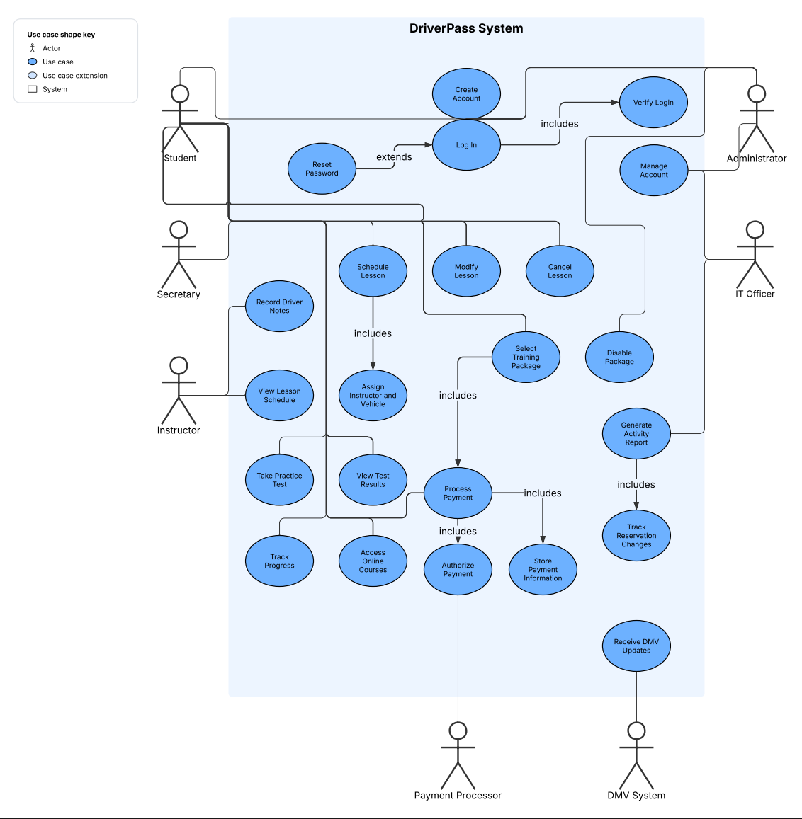

UML Activity Diagrams
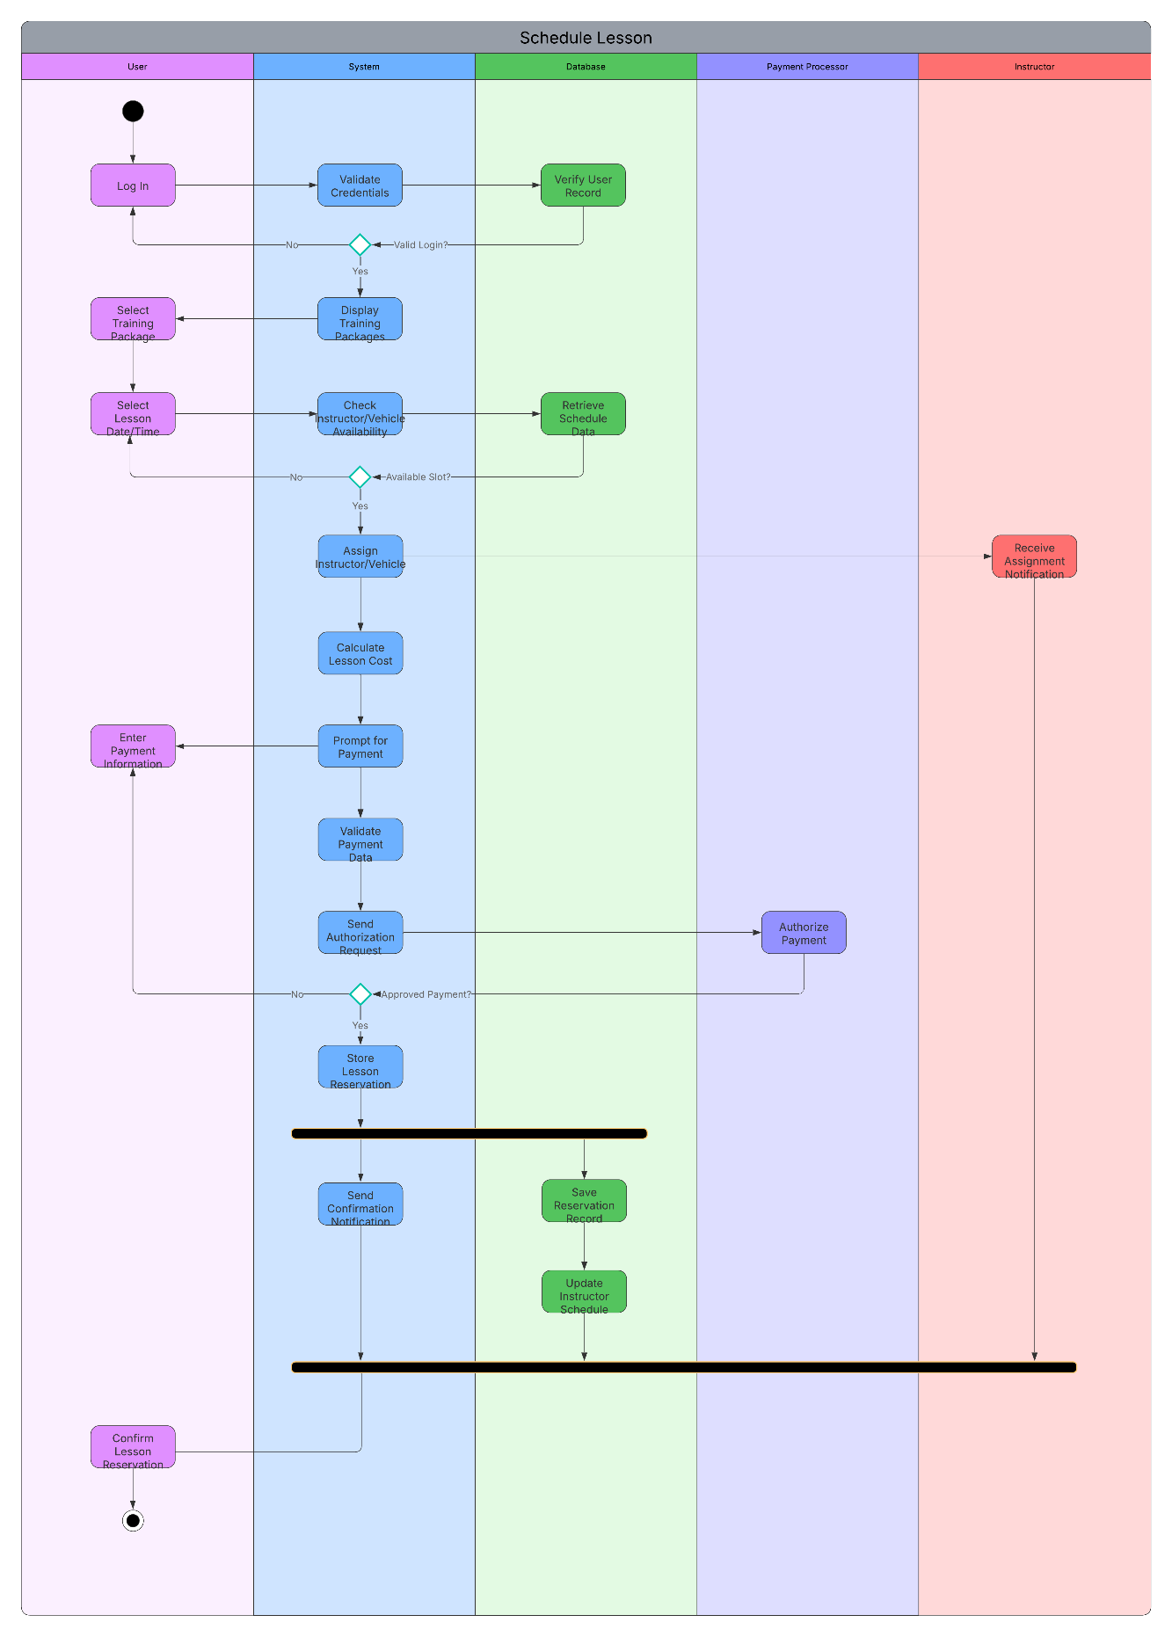

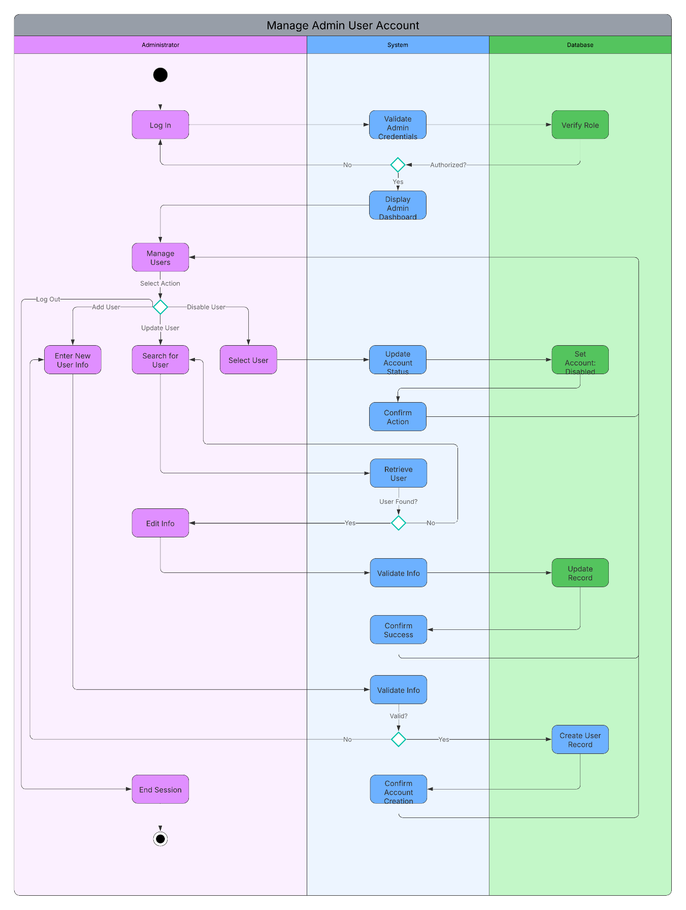

UML Sequence Diagram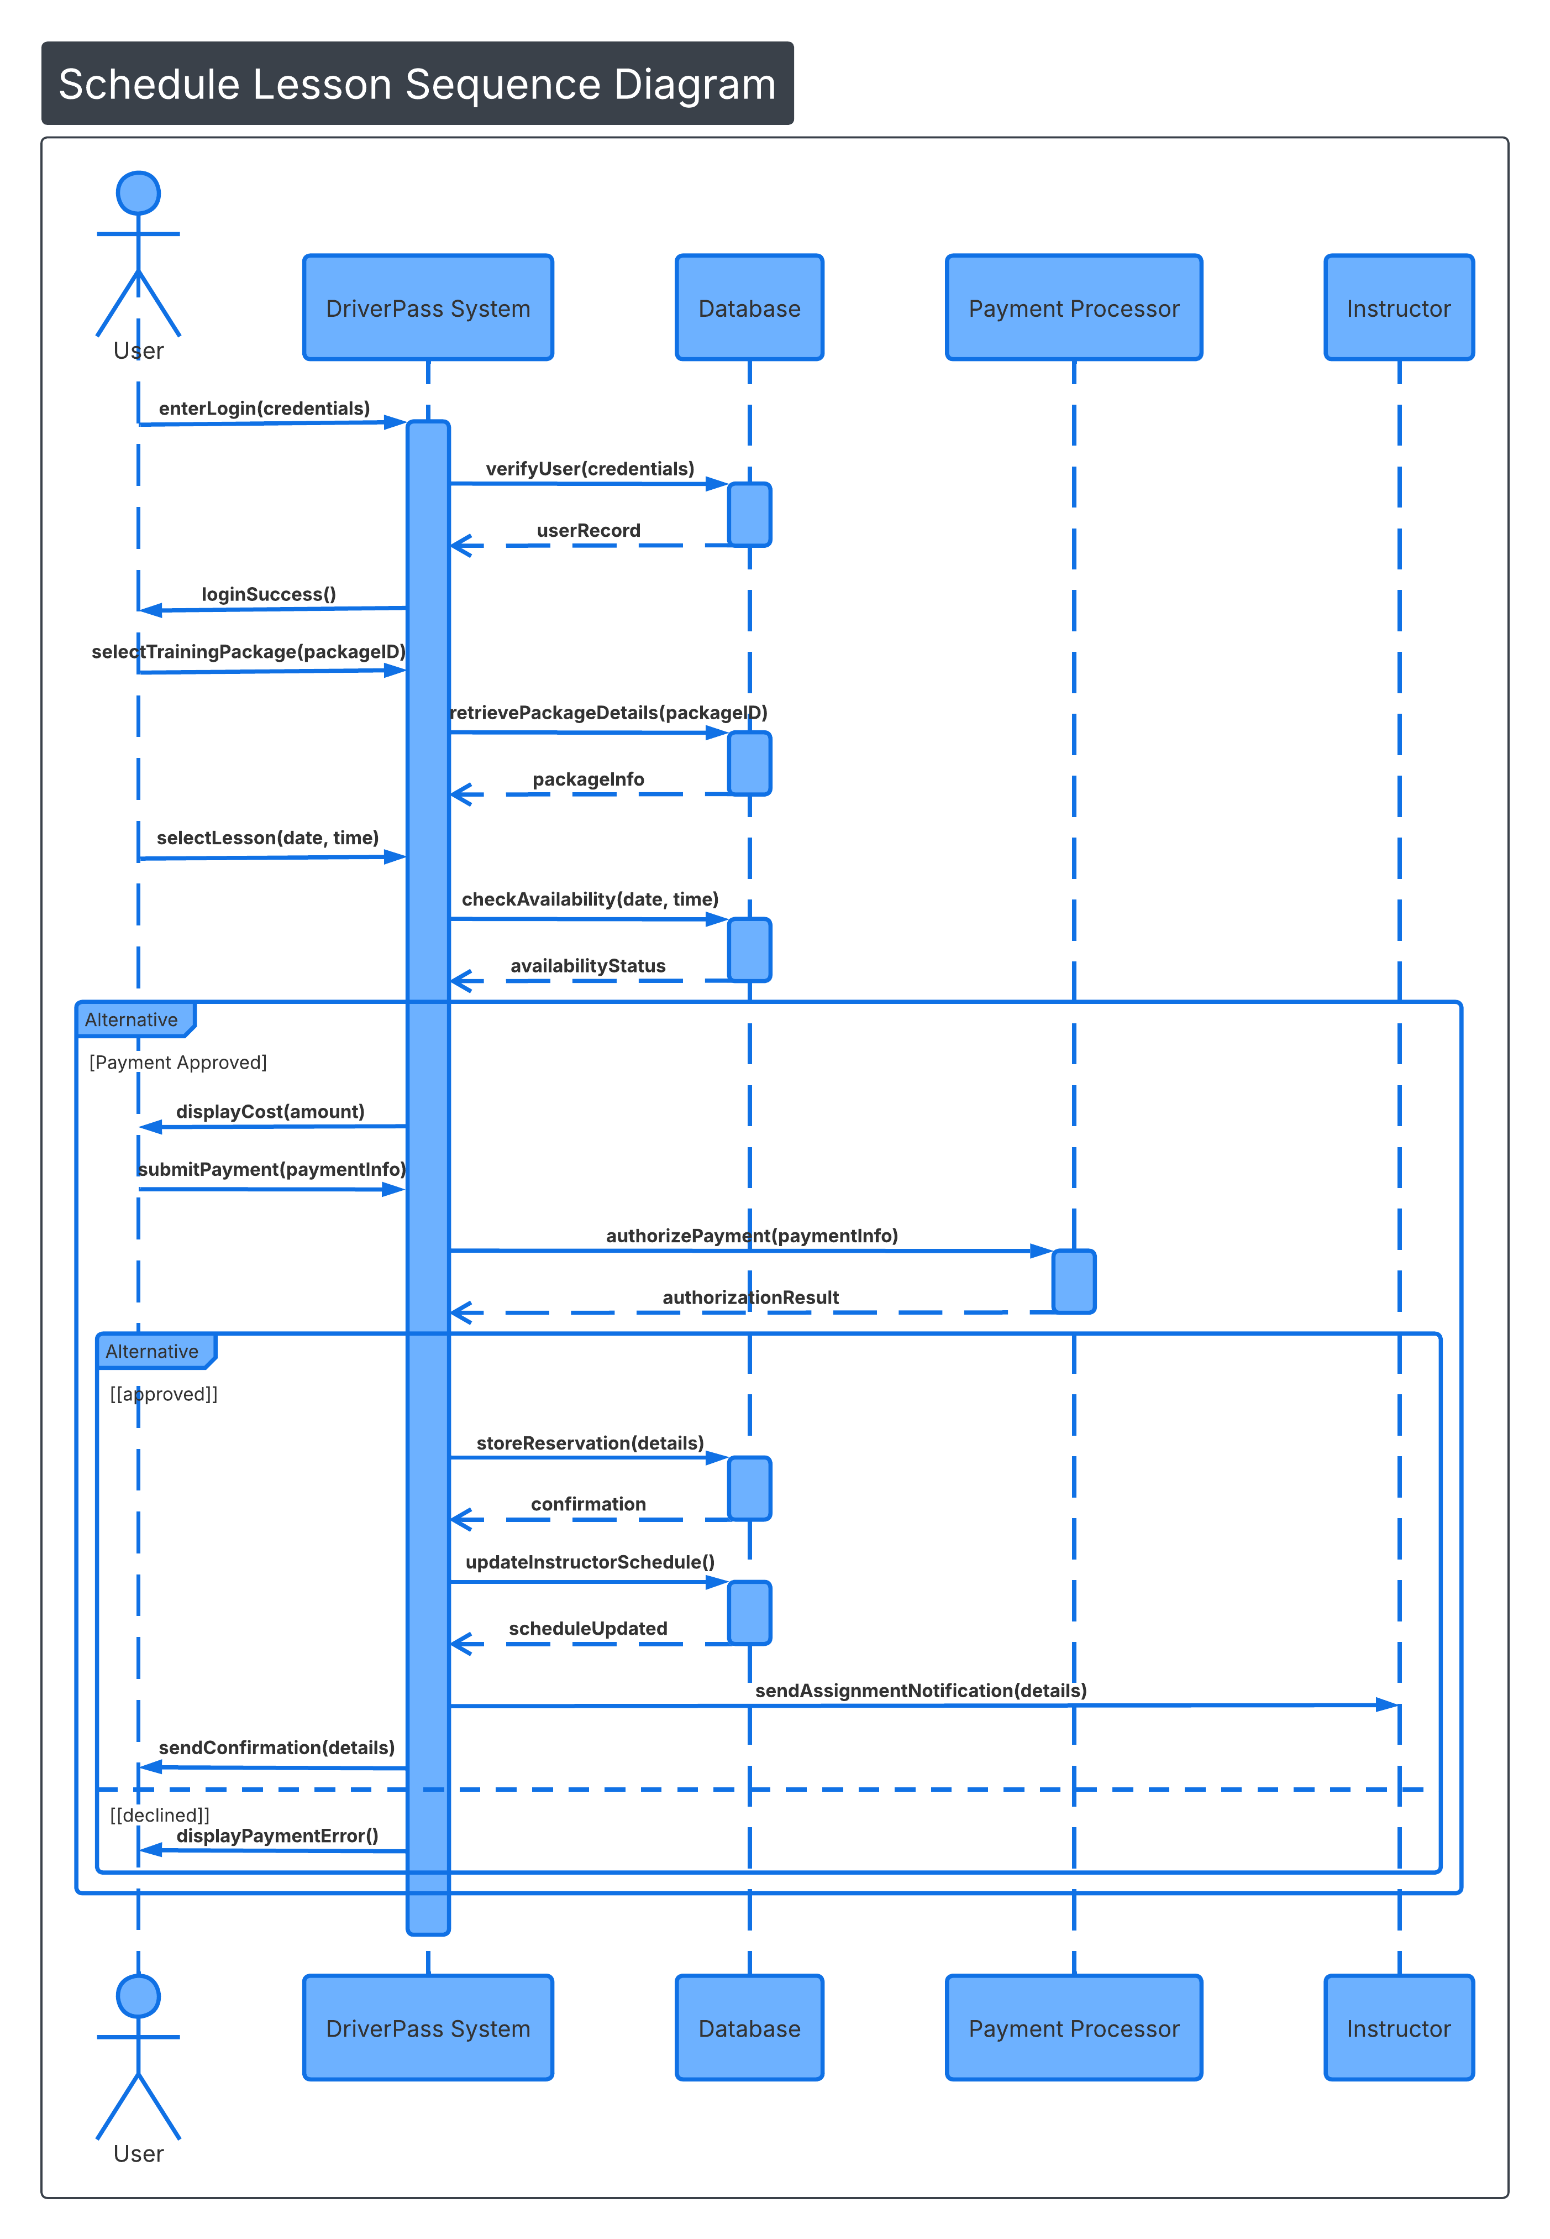

UML Class Diagram
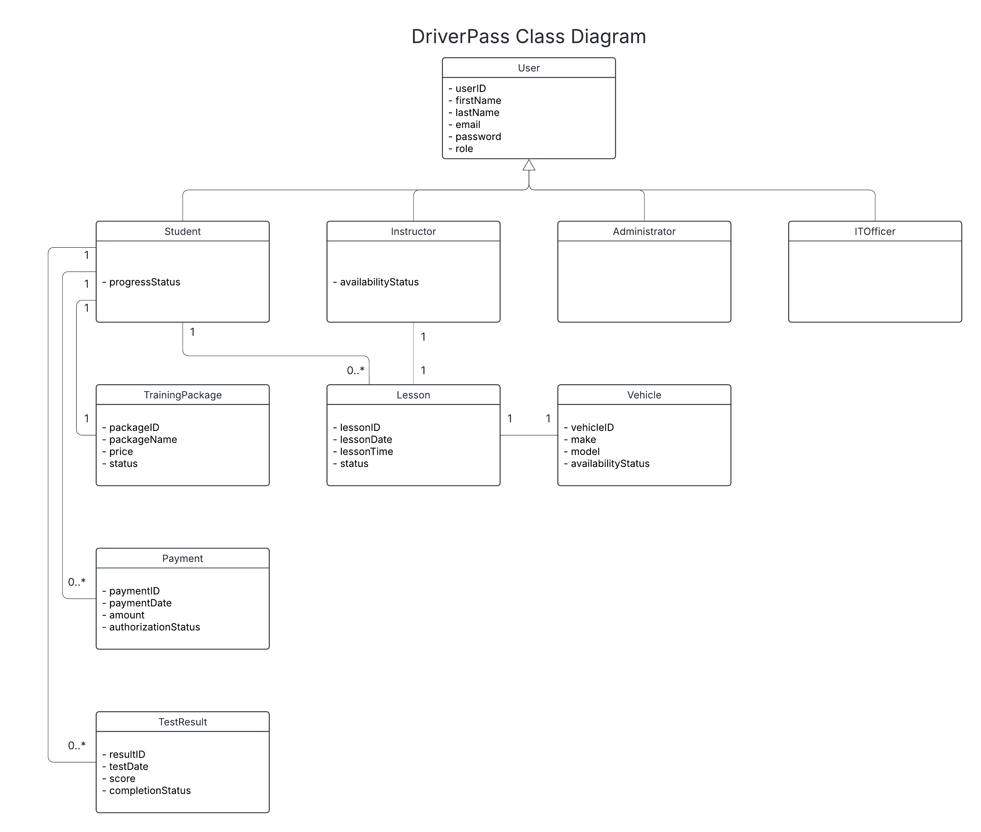

Technical Requirements

Based on the UML diagrams I created for the DriverPass system, the technical requirements include the hardware, software, and infrastructure needed to support a secure web-based application. The system would require a web server to run the application and a database server to store information such as user accounts, lesson schedules, payments, vehicles, and test results. These servers could be hosted on physical hardware or through a cloud provider. On the user side, students, instructors, administrators, and IT officers would only need a device with internet access and a modern web browser to access the system.

From a software perspective, the system would need a backend framework to handle business logic and a relational database management system to manage stored data. Since the system processes payments, it must also securely integrate with a third-party payment processor. To protect user data and financial information, all communication should be encrypted using HTTPS, and passwords should be securely stored in the database.

In terms of infrastructure, the system should be hosted in a secure environment with reliable internet connection, proper network protection, and backup capabilities. Role-based access control is also necessary to ensure that students, instructors, administrators, and IT officers only have access to the features appropriate for their role. The DriverPass system requires secure and scalable web-based architecture that supports user management, lesson scheduling, and payment processing in an efficient and reliable way.

